Google Scholar
Google scholar indexes scholarly materials and searches across all ONU databases. When the Library Links setting is configured for Olivet Nazarene University, you can link to full text in our subscription databases, plus free articles sources online.

Navigation
- Go to the Library website, library.olivet.edu
- Click the “Journals & Articles” tab.
- Click the heading, “Google Scholar”
Note: If the “Fulltext@ONU” is not showing up, follow the instructions found under Google Scholar - “Google Scholar Configuration Instructions.” This is especially important if you are off campus using Google Scholar on a new device.

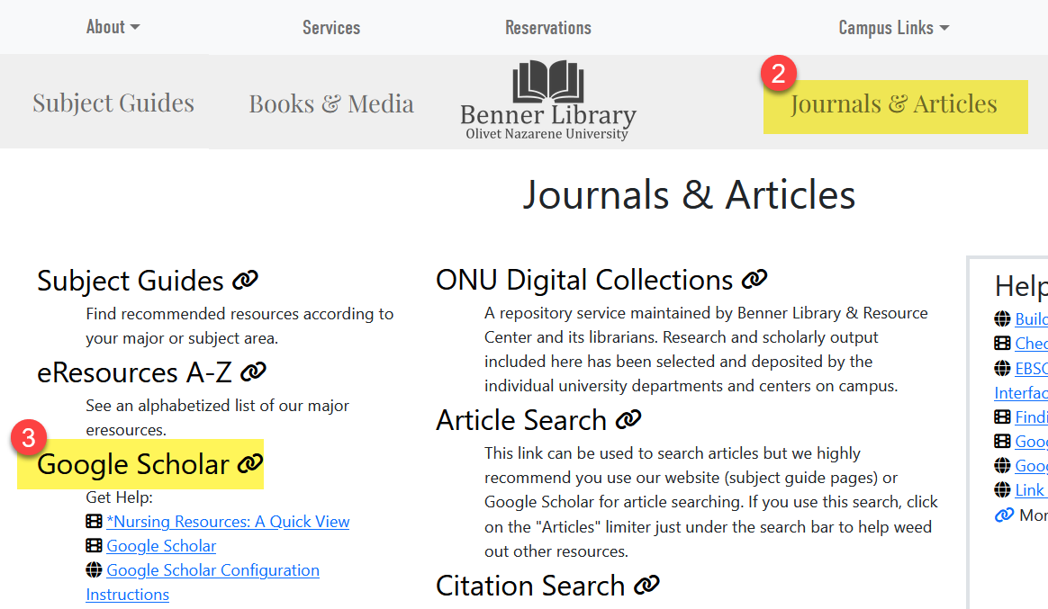

Searching Google Scholar
- Type a few keywords that describe your interest in the Google Scholar search bar.
- Click the search button.
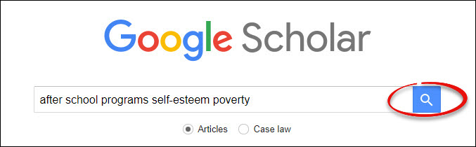

Refining your results
- Click the “hamburger” menu in the top left of the page, scroll down, and click Advanced Search.
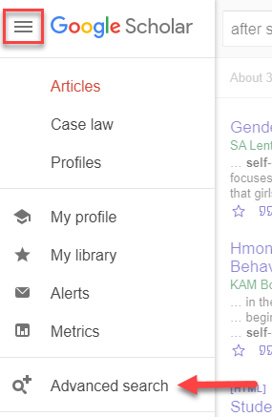
Use the option in the pop-up to refine your search.
- Add quotations around phrases in the search bar titled with all the words to create a Phrase Search.
- In the third search box titled with at least one of the words, add the words “research method study.”
- Limit the date range using the box towards the bottom of the advanced search titled return articles dated between.
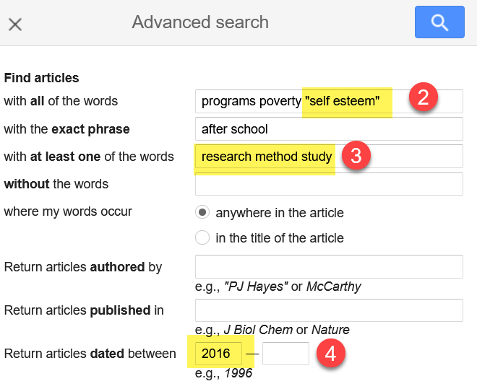
- Click the blue search button in the upper right corner.
- Scroll through the articles. Read abstracts to check for relevancy.
Note: Look for the words like quantitative or qualitative and number of participants for evidence that the author conducted the research and is not reporting someone else’s work.

Accessing Full text
- Click the link on the right side of any search result to get full text for a specific article. If there is no link to the side of a search result, follow Steps 2-4 to request full text:
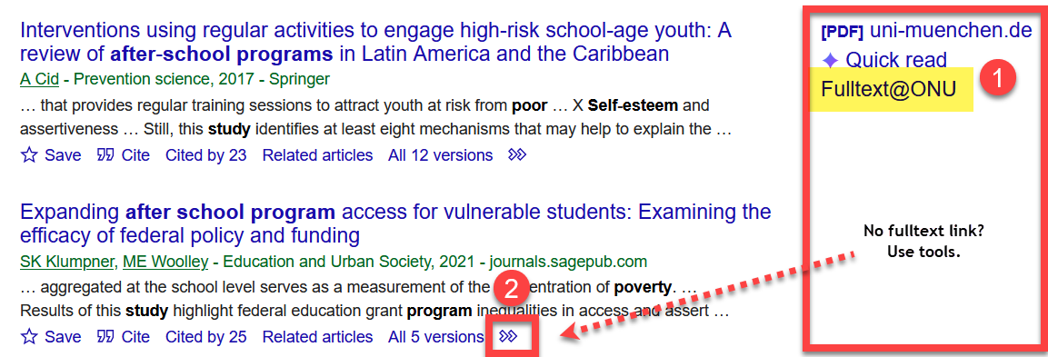
- Click the double arrow below the article title to open the tool.
- Then click the “check for fulltext” link. Sign in to send a request for the article to the Interlibrary Loan Department.
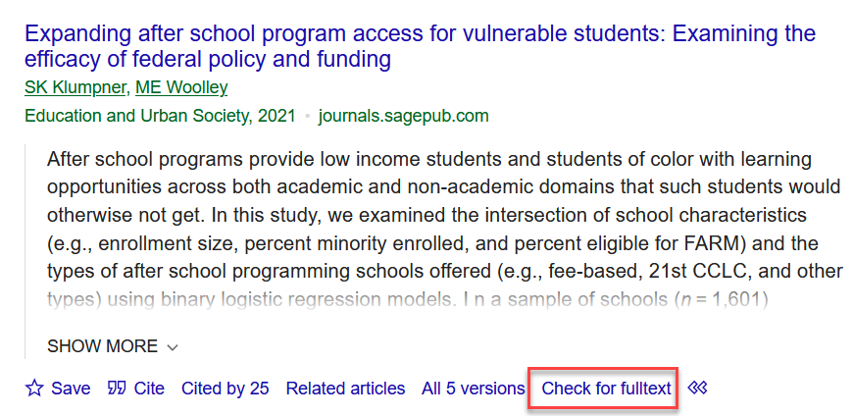
Note: Google Scholar also indexes physical books and ebook chapters. Use Interlibrary Loan to request what you need.

Citating the source
Click the “quotation marks” icon underneath any article. The citation for the article will be formatted for various writing styles such as MLA, APA, and more. Always check the citation formatting, they are often not correct.
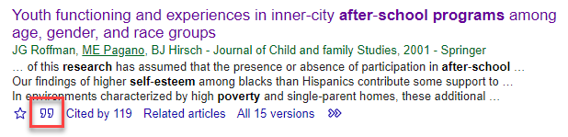

Find more articles like this
- Click the “Related articles” link located underneath the article title to see a list of articles with shared citations and keywords.
- To find newer articles, click the “Cited by” link. The articles linked from this tool each included this article in their bibliography.
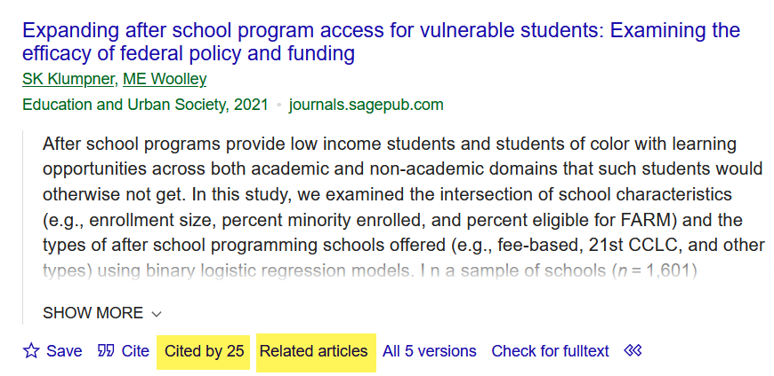
When you click “Cited by” a new list of results is displayed. You’ll know that you are looking at only the articles which cited the original article because the number of results is much smaller than a normal Google Scholar search. To find a keyword, methodology, or author within these few articles, click the “Search within citing articles” checkbox, located under the search box at the top of the page, and add your search words.
