How to Web Print
Revised 9/9/2026

- Begin on the library homepage, https://library.olivet.edu.
- Click on “Web Printing” icon near bottom of homepage.
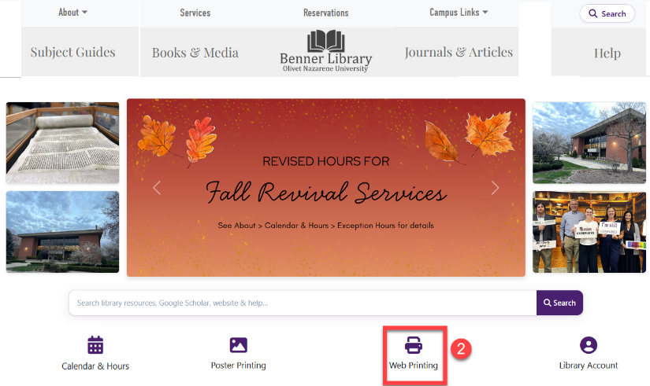
- Login with ONU username and password
- Click “Submit a Job” button.
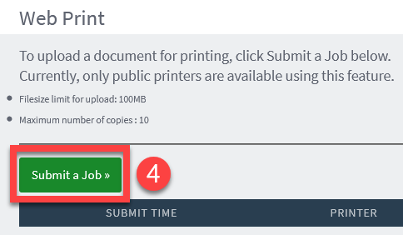
- Select a print method by clicking on one of the blue printer links. Options include:
  - Single or double sided; color or black and white.
  - To print from the bypass tray, choose BWBypass or ColorBypass.
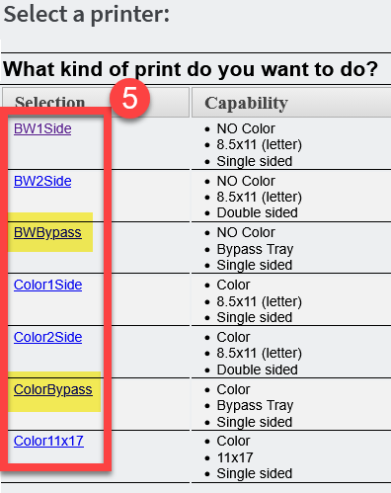
- Click the blue link to confirm your print option.
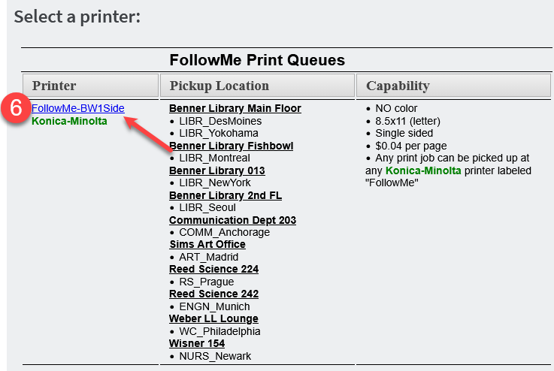
- Click the “Upload Documents” button. Upload as many files as you want—they will all be printed using the same method you selected (e.g. BW1Side). Search for files or drag and drop onto the web printing page.
- Click “Upload & Complete” button.
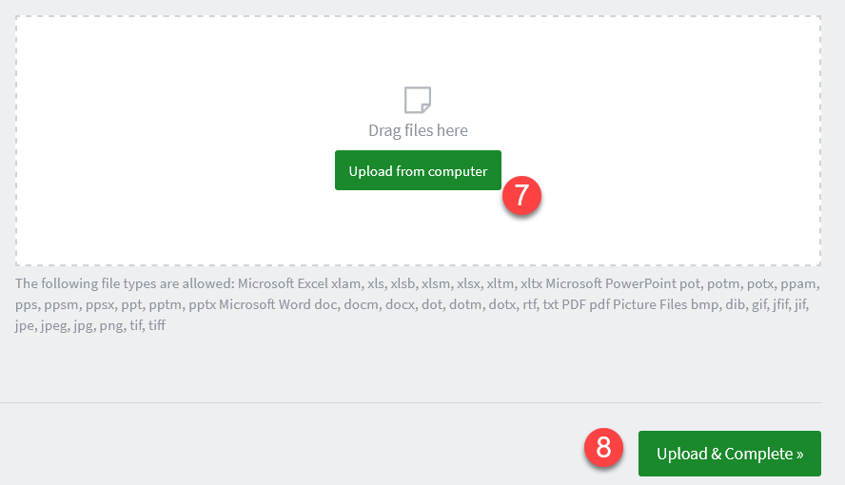
- Go to any printer on campus to release your print job. TigerDollars are required to print.
If you chose “bypass” add paper to the bypass tray and confirm settings for the correct paper size on the printer screen. Be sure the paper size you select matches the paper you inserted into the tray.

